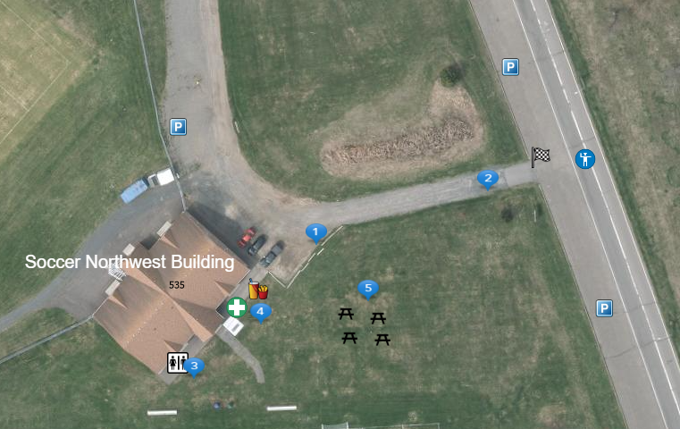
Thunder Bay Law Enforcement Torch Run – Chapples Park September 14, 2025

- Registration Area
- Run/Walk staging area
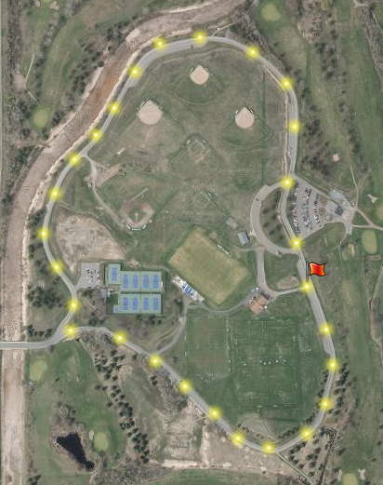
- Washrooms
- First Aid/Food area
- Seating Area (BYO Chairs)

Participants will begin and end at the Soccer Northwest Building – Flagged locations on both maps.
Participant run/walk route is highlighted in yellow

